DAY 4: HANDS ON SUBNETTING PRECITAL
- Given a network address of 192.168.10.0/24, divide it into 4 equal subnets and write down the subnet mask, network address, and broadcast address for each subnet.
Answer
Dividing 192.168.10.0/24 into 4 equal subnets
To create 4 equal subnets we borrow 2 bits → new prefix = /26
Subnet mask = 255.255.255.192
Block size = 64
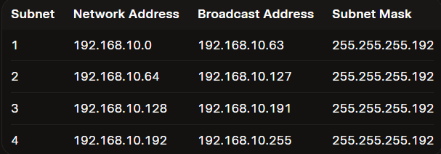

- For one of the subnets you created, assign valid IP addresses to 5 devices (such as a router, two laptops, a printer, and a mobile) and list which IP goes to which device.<br><br><em><strong>Hint:</strong> Make sure not to use the network or broadcast address for any device.</em>
Answer
Selected Subnet: 192.168.10.0/26
(Network: 192.168.10.0 | Broadcast: 192.168.10.63 | Usable range: 192.168.10.1 – 192.168.10.62)\
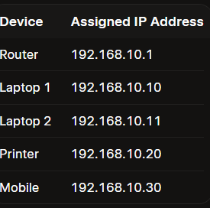

- Draw a simple diagram (hand-drawn or digital) showing your subnet plan: label each subnet, the range of IPs, and where each device is connected.
Answer
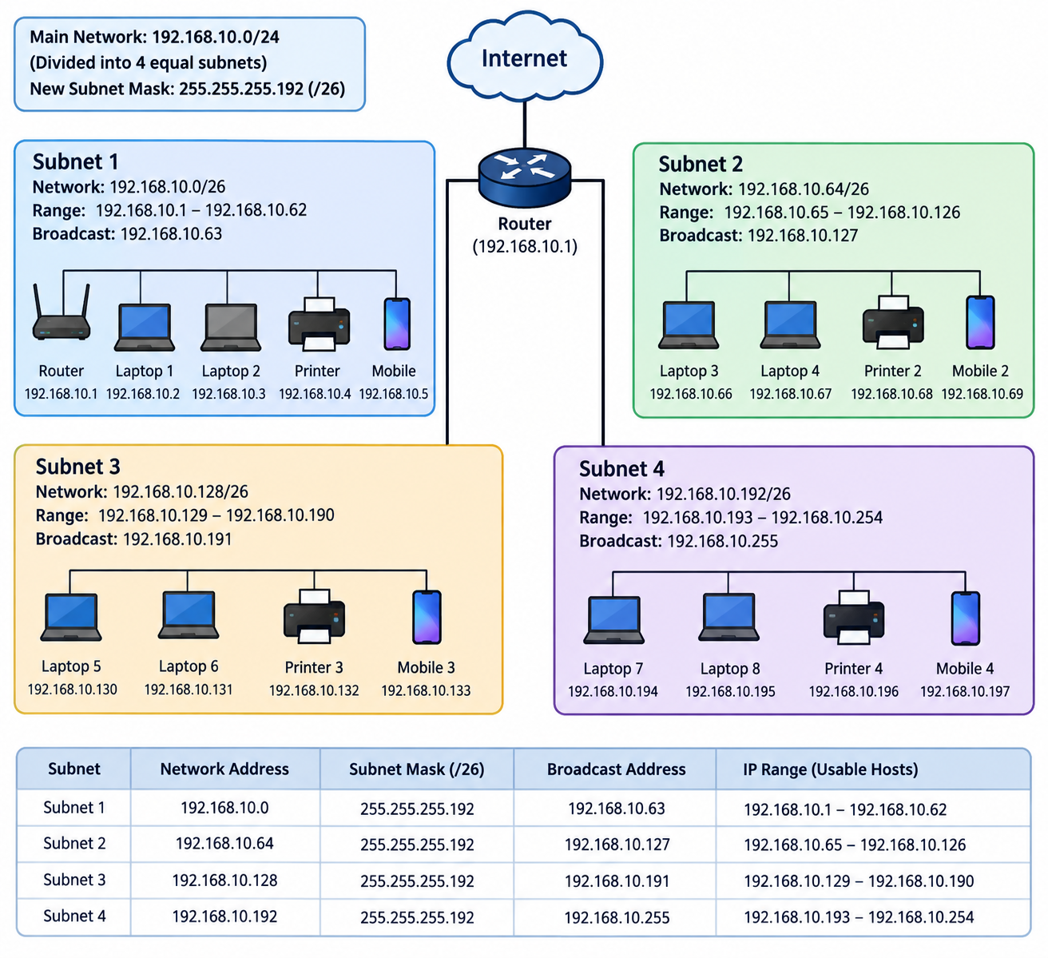

- Document step-by-step how you calculated the subnet mask, number of hosts per subnet, and assigned IP addresses for your plan, as if you are explaining it to a friend who is new to subnetting.
Answer
Step 1: Figure Out How Many Bits to Borrow
An IPv4 address has 32 bits in total. The /24 in 192.168.10.0/24 means the first 24 bits belong to the network (the house address), and the remaining 8 bits belong to hosts (the rooms inside).
To make 4 subnets, we ask: 2 raised to what power equals 4?
- $2^{2}=4$
So, we borrow 2 bits from the host side to expand our network identifier.
- New prefix: $24+2=/26$
Step 2: Calculate the New Subnet Mask
A subnet mask uses 1s for network bits and 0s for host bits.
- 32-bit binary for /26: 11111111.11111111.11111111.11000000
- Convert the 4th octet (11000000) to decimal:
$$128+64=192$$
Our new subnet mask for all 4 subnets is 255.255.255.192.
Step 3: Find the Total & Usable Hosts per Subnet
Now look at the remaining host bits. Since we borrowed 2 bits out of 8, we have 6 host bits left ($32-26=6$).
- Total IPs per subnet: $2^{6}=64\text{ addresses}$
- Usable IPs per subnet: $64-2=62\text{ hosts}$
Why subtract 2? Every single subnet reserves two special IPs that devices cannot use:
- Network ID (the very first address): Identifies the subnet itself.
- Broadcast Address (the very last address): Used to blast data to every device on that subnet simultaneously.
Step 4: Map Out the 4 Subnets (The Block Size Method)
Our block size (or increment) is 64. This means each subnet starts 64 numbers higher than the last one:
- Subnet 1: Starts at .0 $→$ Ranges 192.168.10.0 to .63
- Subnet 2: Starts at .64 $→$ Ranges 192.168.10.64 to .127
- Subnet 3: Starts at .128 $→$ Ranges 192.168.10.128 to .191
- Subnet 4: Starts at .192 $→$ Ranges 192.168.10.192 to .255
Step 5: Assign IPs to Devices (Using Subnet 1)
For Subnet 1, our usable host pool runs from 192.168.10.1 to 192.168.10.62 (leaving .0 for Network ID and .63 for Broadcast).
We assign them logically across our network setup:
- 192.168.10.1 $→$ Gateway Router: Standard practice to give the default gateway the very first usable IP.
- 192.168.10.2 $→$ Laptop 1: Next available host IP.
- 192.168.10.3 $→$ Laptop 2: Next available host IP.
- 192.168.10.4 $→$ Printer: Assigned a static IP so it doesn't change on the network.
- 192.168.10.5 $→$ Mobile Phone: Next available host IP.

